Accessibility Tools Overview

Select and Add Remediation Tools
To make documents you will have to select them from the tool’s menu.
- Select “Tools”.
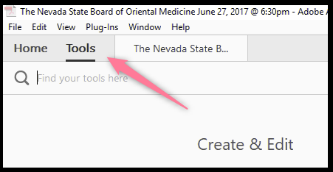

Add Accessibility Tools Right Side
The seven tools that will be added to the right side of Adobe Acrobat Pro and will help with remediating PDF documents are:
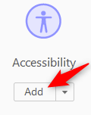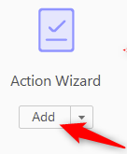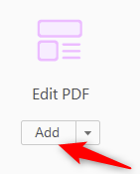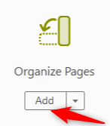
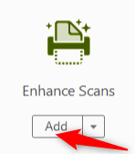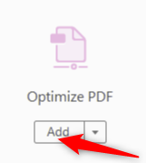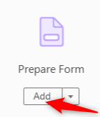

Once you have added the remediation tools they will be located on the right panel for future use.

Add Accessibility Tools Left Side
Using a keyboard mouse, Right click on the left side of Adobe Acrobat Pro DC:
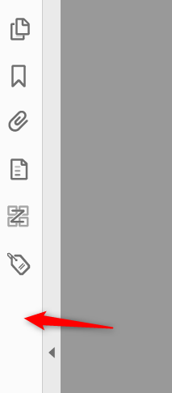
The Three tools that are added to the left side of Adobe Acrobat Pro and will help with remediating a PDF document. The three tools to add:
